PASSWORD ENCRYPTION AND DECRYPTION JAVA PROJECT Using Cryptography

INTRODUCTION
This project aims to explore the best practices of password management by using encryption and decryption methods in Java programming language.
Now, let me explain what encryption and decryption methods are. Encryption is a process of converting plain text into a coded message, also known as cipher text, that cannot be easily understood by unauthorized individuals. Decryption, on the other hand, is the reverse process of converting cipher text back into plain text. The objective of encryption is to protect sensitive data and ensure confidentiality, while decryption enables authorized individuals to access the original message.
In this project, we will be using two different types of encryption algorithms: Symmetric Algorithm and Asymmetric Algorithm. Symmetric Algorithm uses a single key for both encryption and decryption of data, which means that the same key used for encryption must be used for decryption. Asymmetric Algorithm uses two different keys, one for encryption and one for decryption. In this case, the public key is used for encryption, while the private key is used for decryption.
To decrypt the encrypted data, we will be using different decryption methods, including Triple DES, RSA, Blowfish, Twofish, and AES. Triple DES, also known as 3DES, is a symmetric encryption algorithm that uses three keys to encrypt and decrypt data. RSA, or Rivest–Shamir–Adleman, is an asymmetric encryption algorithm that uses public and private keys for encryption and decryption, respectively. Blowfish and Twofish are symmetric encryption algorithms that use variable key lengths to provide enhanced security. Finally, AES, or Advanced Encryption Standard, is a symmetric encryption algorithm that uses a fixed key length and is widely used for data encryption.
In summary, this project will delve into the different encryption and decryption methods, including Symmetric and Asymmetric Algorithms, and the decryption methods such as Triple DES, RSA, Blowfish, Twofish, and AES. By understanding these methods, developers can implement secure password management techniques in their applications to protect sensitive information from unauthorized access.

Explaination Section

cryptography
Cryptography is the practice of securing information by converting it into a code that only someone with the right key can understand.
For example, if I want to send a private message to my friend, I might use cryptography to scramble the message so that no one else can read it. My friend would then use the key to unscramble the message and read it.
In summary, cryptography is a way of protecting information by converting it into a code that only someone with the right key can understand. It's like putting a lock on a box to keep its contents safe.

ENCRYPTION ALGORITHMS
Encryption algorithms are a set of rules that are used to scramble information so that only someone with the right key can unscramble it.
Imagine that you're sending a secret message to your friend. You use an encryption algorithm to turn the message into a jumbled mess of letters and numbers that no one else can read. Then, you send the encrypted message to your friend, who uses the key to unscramble the message and read your secret message.
In summary, encryption algorithms are used to scramble information so that it can only be unscrambled by someone with the right key. It's like putting a secret code on a message to keep it private.

Symmetric algorithms
Symmetric algorithms are a type of encryption algorithm that use the same key for both encrypting and decrypting information.
If I want to send a secret message to a friend, I can utilize a symmetric algorithm that will scramble the message using a key, making it unreadable without the key.
When my friend receives the encrypted message, they use the same key to unscramble it, turning it back into the original message that I sent.
In summary, symmetric algorithms work by using a single key to scramble information that can only be unscrambled by someone with the key. It's like having a secret code that only the people who know it can understand.

AES
AES stands for Advanced Encryption Standard, and it is a widely used encryption algorithm in cryptography that uses a symmetric key to encrypt and decrypt information.
Let me give you an example to help explain how it works. Imagine I want to send a secret message to my friend, and I want to use AES encryption to keep it private. Here's how the process might work:
- First, I take the message I want to send and divide it into blocks of 128 bits each.
- Next, I use a secret key to create a unique set of "round keys" for each round of the encryption process.
- The first round of encryption involves substituting each byte of data with another byte of data according to a fixed substitution table, using the first-round key.
- Then, a process called "permutation" is used to shift the positions of the bytes in each block.
- This process is repeated for several rounds, with each round using a different round key.
- The final round produces the encrypted message, which can only be decrypted using the same key that was used to encrypt it.
Once my friend receives the encrypted message, they can use the same secret key to decrypt it and read my secret message.
In summary, AES encryption is a widely used encryption algorithm in cryptography that uses a symmetric key to encrypt and decrypt information. It involves dividing the information to be encrypted into blocks, creating unique "round keys" for each round of encryption, and using a process of substitution and permutation to encrypt the data.

Asymmetric Algorithms
Asymmetric algorithms, also known as public-key cryptography, are a type of encryption algorithm that uses two different but mathematically related keys: a public key and a private key. Here's an explanation in layman's terms:
When we want to send a message to someone, we usually have to agree on a secret key that we'll both use to encrypt and decrypt the message. But with asymmetric encryption, we don't need to share a secret key because we use two keys instead.
To explain further, let's say I want to send a secret message to my friend. I would use their public key, which is like a digital padlock, to encrypt the message. My friend would then use their private key, which is like a digital key that unlocks the padlock, to decrypt the message.
The beauty of this system is that my friend can safely share their public key with anyone, because no one can use it to decrypt messages without the corresponding private key. That means that even if someone intercepts our encrypted message, they won't be able to read it without the private key.
Asymmetric encryption is commonly used for secure online transactions, such as shopping or banking. When you enter your credit card information into a website, the website uses asymmetric encryption to encrypt the information using its public key. The website's server then uses its private key to decrypt the information and process your transaction.
In summary, asymmetric algorithms are a type of encryption algorithm that uses a public key and a private key to encrypt and decrypt messages without needing to share a secret key.

RSA
RSA is a type of encryption algorithm that stands for Rivest-Shamir-Adleman, the last names of its inventors. It's a form of public-key cryptography, which means that it uses two keys - a public key and a private key - to encrypt and decrypt messages.
Here's a step-by-step guide to how RSA encryption works:
- Key generation: The first step in RSA encryption is to generate a key pair consisting of a public key and a private key. The public key can be freely distributed to anyone who wants to send you an encrypted message, while the private key is kept secret and used for decrypting messages.
- Encryption: To send a message to someone using RSA encryption, you would first obtain their public key. You would then use their public key to encrypt the message you want to send.
- Decryption: When the encrypted message is received, the recipient would use their private key to decrypt it. This is the only key that can decrypt the message, so it's important that the private key is kept secure.
- Security: The security of RSA encryption is since it's very difficult to factor large prime numbers. The larger the key size used in RSA encryption, the more secure it is against brute force attacks.
RSA encryption is used in many applications where secure communication is important, such as online banking and email communication. Because the public key can be safely shared, RSA encryption is a convenient way to send messages securely without needing to share a secret key.
In summary, RSA encryption is a form of public-key cryptography that uses a key pair consisting of a public key and a private key to encrypt and decrypt messages. It's based on the difficulty of factoring large prime numbers and is used in many applications where secure communication is important.

decryption Algorithms
Decryption algorithms are a type of cryptographic algorithm that are used to reverse the process of encryption. Encryption is the process of taking plain text and converting it into a coded message (or ciphertext) using an encryption algorithm, while decryption is the process of converting the ciphertext back into plain text using a decryption algorithm.
Decryption algorithms are a type of cryptographic algorithm that are used to reverse the process of encryption. Encryption is the process of taking plain text and converting it into a coded message (or ciphertext) using an encryption algorithm, while decryption is the process of converting the ciphertext back into plain text using a decryption algorithm.
One example of a decryption algorithm is the Advanced Encryption Standard (AES), which is a widely used symmetric key encryption algorithm. AES encryption uses a secret key to encrypt data, and the same key is used to decrypt the data back into its original form.
Here's how AES decryption works in simple terms:
- Get the encrypted message: To decrypt a message, you first need to obtain the ciphertext (the encrypted message) that was generated using the AES encryption algorithm.
- Use the secret key: To decrypt the message, you need to use the same secret key that was used to encrypt the message in the first place. If you don't have the secret key, you won't be able to decrypt the message.
- Decrypt the message: Once you have the encrypted message and the secret key, you can use the AES decryption algorithm to decrypt the message back into its original plain text form.
- Verify the decrypted message: It's important to verify that the decrypted message is the same as the original plain text message. This can be done by comparing the decrypted message with the original message to make sure they match.
Here's how RSA decryption works in simple terms:
- Get the encrypted message: To decrypt a message that has been encrypted using RSA, you first need to obtain the encrypted message (the ciphertext).
- Use the private key: To decrypt the message, you need to use the private key that corresponds to the public key used to encrypt the message. The private key should be kept secret and not shared with anyone.
- Decrypt the message: Once you have the encrypted message and the private key, you can use the RSA decryption algorithm to decrypt the message back into its original plaintext form.
- Verify the decrypted message: It's important to verify that the decrypted message is the same as the original plaintext message. This can be done by comparing the decrypted message with the original message to make sure they match.
Decryption algorithms are an important part of modern cryptography, as they allow for secure communication and data storage by ensuring that only authorized users can read sensitive information. Without decryption algorithms, encrypted messages would be unreadable and the entire purpose of encryption would be defeated.
In summary, decryption algorithms are a type of cryptographic algorithm used to reverse the process of encryption. They are used to securely decode messages and ensure that only authorized users can access sensitive information. An example of a decryption algorithm is AES, which is a widely used symmetric key encryption algorithm.

DESede
DESede, also known as Triple DES, is a symmetric key encryption algorithm that is used to protect sensitive data. It works by taking a plaintext message and using a secret key to transform it into ciphertext, which can then be safely transmitted or stored. The key used in the encryption and decryption process must be kept secret.
The algorithm works by applying the DES encryption process three times in a row, using two or three different keys. This makes it more secure than the original DES algorithm, which was vulnerable to attacks.
- In simple terms, here's how the DESede algorithm works:
- The plaintext message is broken up into blocks, which are usually 64 bits in length.
- A key is chosen, and the plaintext is encrypted using the DES algorithm.
- The output of the first encryption is then encrypted again using a second key.
- Finally, the output of the second encryption is encrypted again using a third key.
- The resulting ciphertext can then be transmitted or stored safely and can only be decrypted using the same three keys in reverse order.
In summary, DESede is a symmetric key encryption algorithm that uses the DES encryption process three times in a row, with two or three different keys, to protect sensitive data. The resulting ciphertext can only be decrypted using the same three keys in reverse order, making it more secure than the original DES algorithm.

Blowfish
Blowfish is a symmetric key encryption algorithm that is used to protect sensitive data. It works by taking a plaintext message and using a secret key to transform it into ciphertext, which can then be safely transmitted or stored. The key used in the encryption and decryption process must be kept secret.
The algorithm works by breaking the plaintext message into blocks and then encrypting each block separately. Blowfish uses a variable-length key, which can be anywhere from 32 to 448 bits long, making it more secure than some other encryption algorithms.
In simple terms, here's how the Blowfish algorithm works:
- The plaintext message is broken up into blocks, which are usually 64 bits in length.
- A key is chosen, and the first block is encrypted using the Blowfish algorithm.
- The output of the first block is then used to encrypt the next block, and so on until all blocks have been encrypted.
- The resulting ciphertext can then be transmitted or stored safely and can only be decrypted using the same key.
In summary, Blowfish is a symmetric key encryption algorithm that uses a variable-length key to protect sensitive data. The plaintext message is broken up into blocks and each block is encrypted separately using the Blowfish algorithm. The resulting ciphertext can only be decrypted using the same key.

Twofish
Twofish is a symmetric key encryption algorithm that is used to protect sensitive data. It works by taking a plaintext message and using a secret key to transform it into ciphertext, which can then be safely transmitted or stored. The key used in the encryption and decryption process must be kept secret.
The algorithm works by breaking the plaintext message into blocks and then encrypting each block separately. Twofish uses a key size of up to 256 bits, making it more secure than some other encryption algorithms. It also uses a round-based encryption process that involves multiple rounds of substitution and permutation.
In simple terms, here's how the Twofish algorithm works:
- The plaintext message is broken up into blocks, which are usually 128 bits in length.
- A key is chosen, and the first block is encrypted using the Twofish algorithm.
- The output of the first block is then used to encrypt the next block, and so on until all blocks have been encrypted.
- The encryption process involves multiple rounds of substitution and permutation, making it more secure.
- The resulting ciphertext can then be transmitted or stored safely and can only be decrypted using the same key.
In summary, Twofish is a symmetric key encryption algorithm that uses a key size of up to 256 bits to protect sensitive data. The plaintext message is broken up into blocks and each block is encrypted separately using the Twofish algorithm, which involves multiple rounds of substitution and permutation. The resulting ciphertext can only be decrypted using the same key, making it more secure.

Programming Section

foundation code
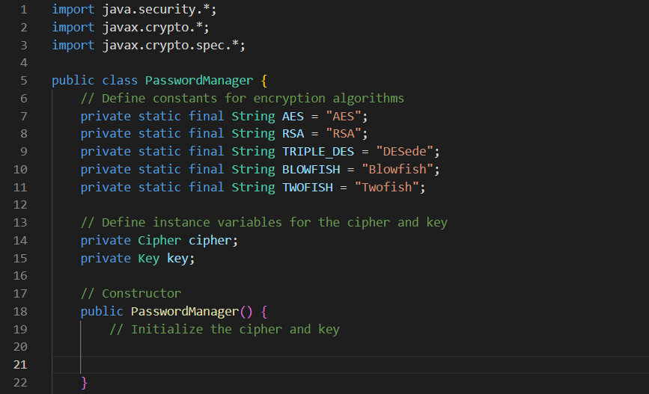
Figure 1: Foundation of Project Part 1
At the top of my code, I define several constants and instance variables. These constants define the different encryption algorithms that my program can use, and the instance variables store the cipher and key that I will use for encryption and decryption.
When I create a new instance of my PasswordManager class, I use the constructor to initialize the cipher and key instance variables.

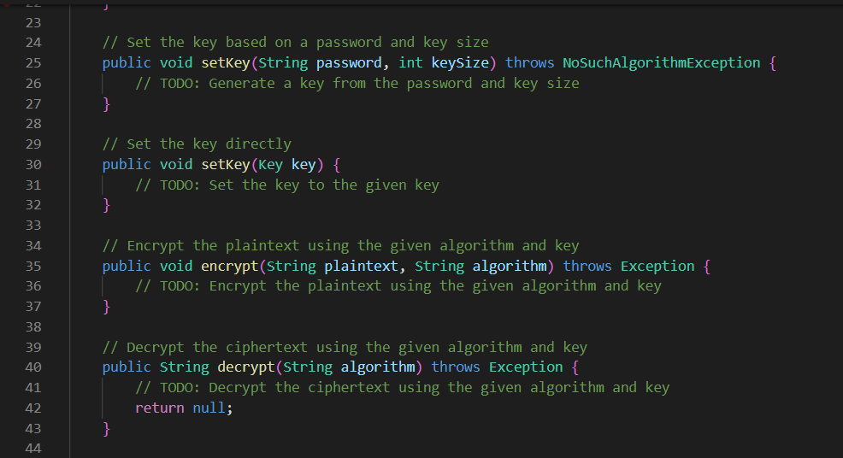
Figure 2: : Foundation of Project Part 2
In my code, there are two setKey methods that I use. The first one requires a password and key size as input, and the second one requires a Key object. With the first method, I generate a key based on the given password and key size, whereas the second method just sets the key to the specified Key object.
My code relies on the encrypt and decrypt methods to perform encryption and decryption operations. Whenever I use the encrypt method, I provide a plaintext string and an encryption algorithm as input to encrypt the plaintext using the given algorithm and key. As for the decrypt method, I use it to decrypt a previously encrypted ciphertext by providing an encryption algorithm as input.

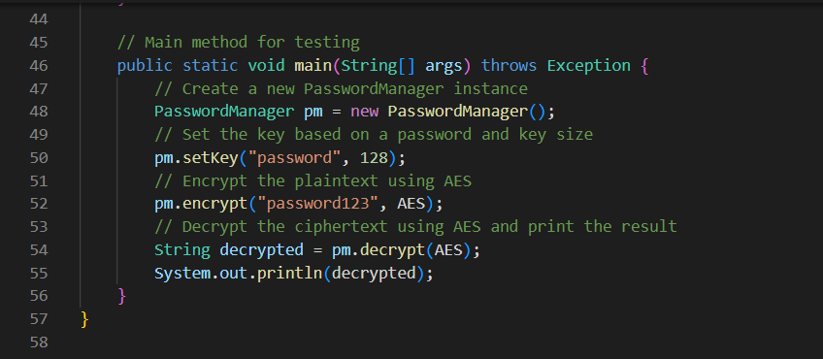
Figure 3 : Foundation of Project Part 3
In my program, the main method is where the program begins and is primarily used to test the PasswordManager class. Its functionality includes creating a new instance of the PasswordManager class, setting the key to a password and key size, encrypting a plaintext string using the AES algorithm, decrypting the ciphertext using the same algorithm, and displaying the decrypted plaintext on the console.

Initialize the Cipher and Key

